

Version Number: 1.0

Version Date: 2019-05-03



**Revision Log**

|  |  |  |  |
| --- | --- | --- | --- |
| **Version** | **Date** | **Author** | **Change Description** |
| 0.1 | 2019-03-28 | Deanna Beauchamp | Initial draft |
| 1.0 | 2019-05-03 | Deanna Beauchamp | Completion of Phase 1 |
|  |  |  |  |
|  |  |  |  |

Contents

1. Introduction 3

2. Target Audience 3

3. Dashboards 3

3.1. Case SLA – PSI Return Date 3

3.2. Case Summary 3

3.3. Financial Summary 4

3.4. Operations Dashboard 5

3.5. Order SLA – In Progress Letter Date 5

3.6. Order SLA – Install Date 6

3.7. Order Summary 7

4. Reports 7

# Introduction

While Dynamics CRM 365 comes with many out of the box dashboards, we are not currently using them. Instead the dashboards listed in this document are custom ones created to target a user’s needs.

# Target Audience

The target audience for this document is Dynamics configuration professionals and administrators.

# Dashboards

## Case SLA – PSI Return Date

Security Roles: All

Apps: NGN App

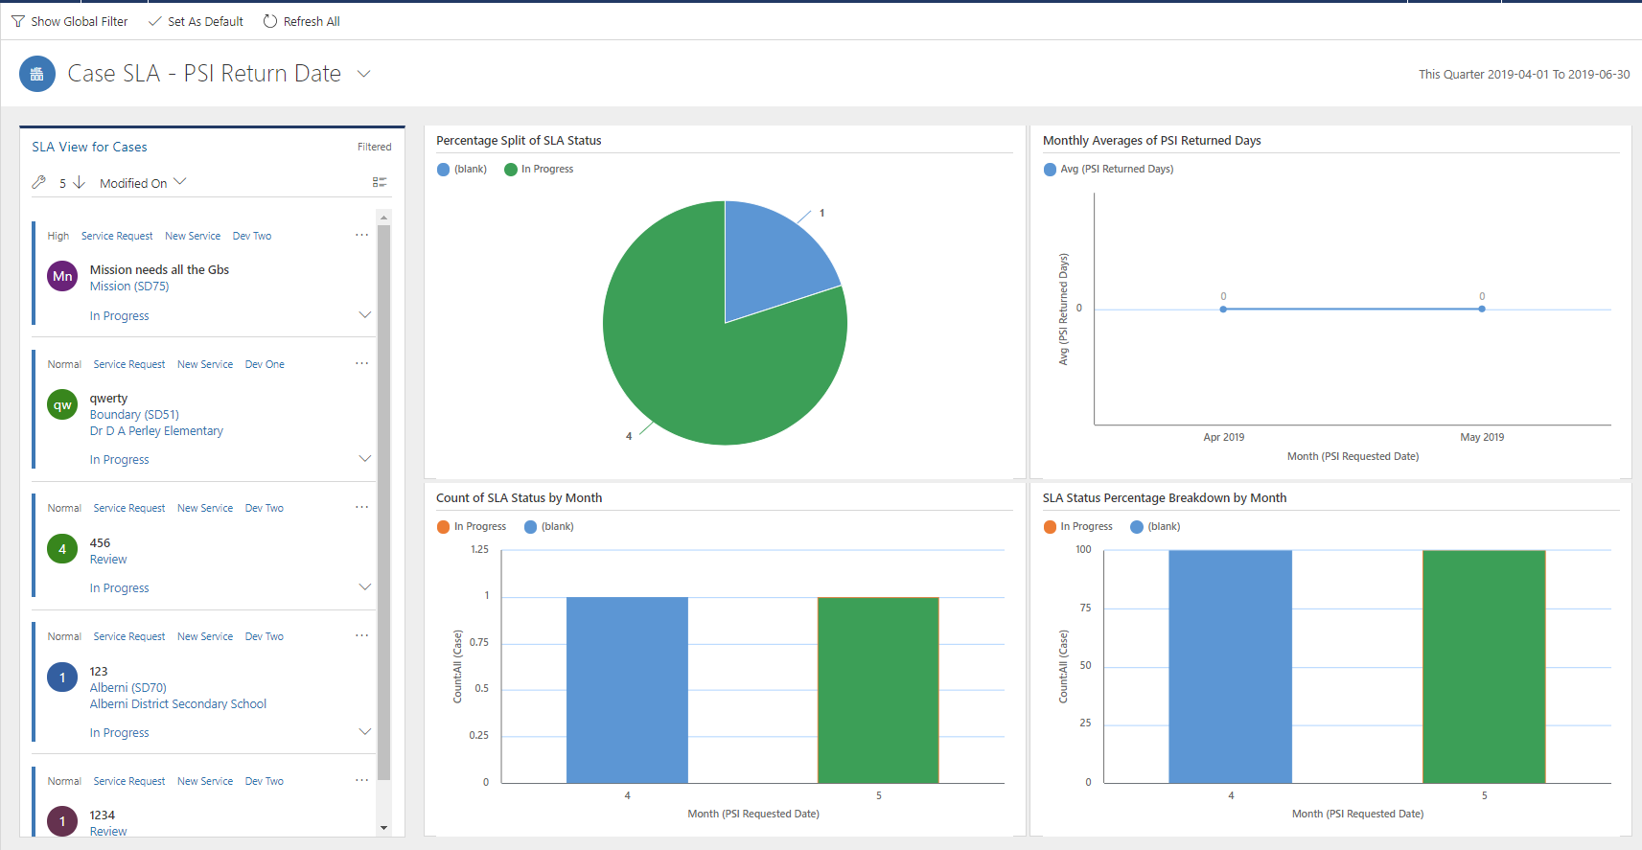

## Case Summary

Security Roles: All

Apps: NGN App

Description: An interactive dashboard showing a summary of cases filtered by created date.

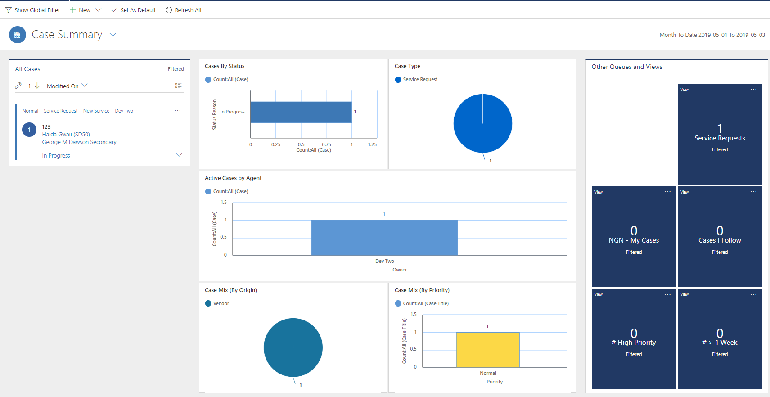

## Financial Summary

Security Roles: All

Apps: NGN App

Description: An interactive dashboard of financial monthly summary records filtered on period end date. Charts shown include variance by category and vendor and a comparison of actual and expected totals.

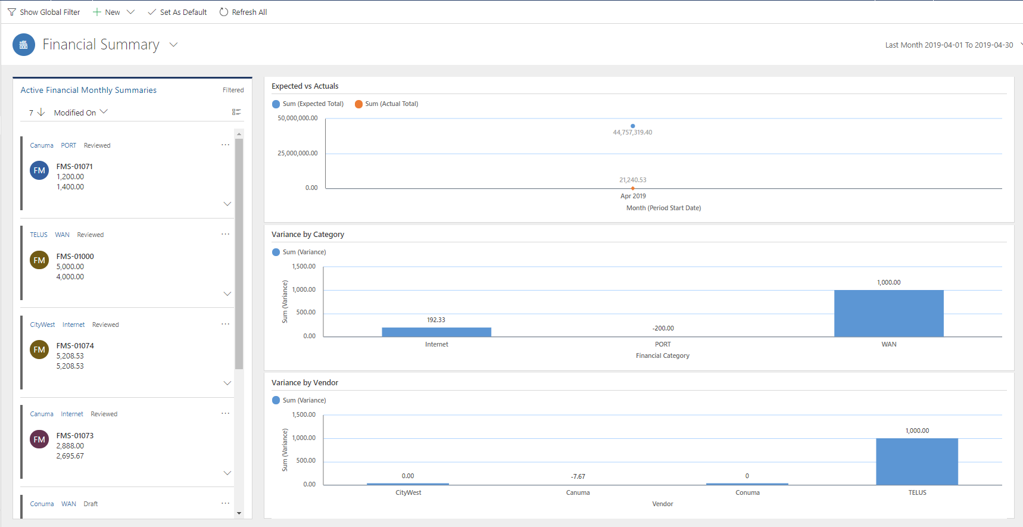

## Operations Dashboard

Security Roles: All

Apps: Main App/NGN App

Description: This dashboard is used by the service delivery managers to manage their day to day operations.

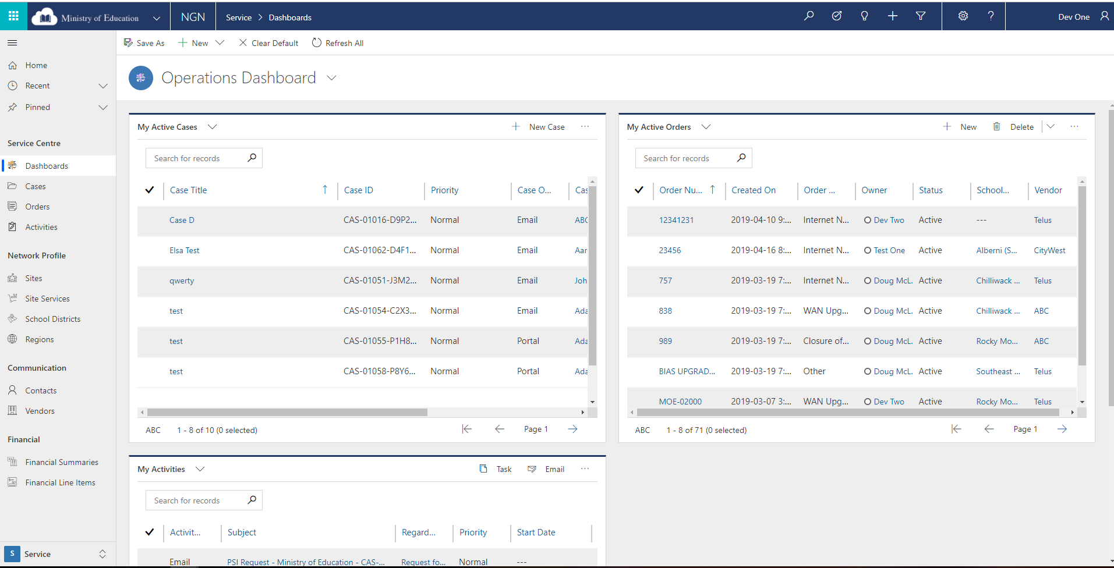

## Order SLA – In Progress Letter Date

Security Roles: All

Apps: NGN App

Description: This interactive dashboard shows how many days it took TELUS to confirm the order with the school district via the in-progress letter.

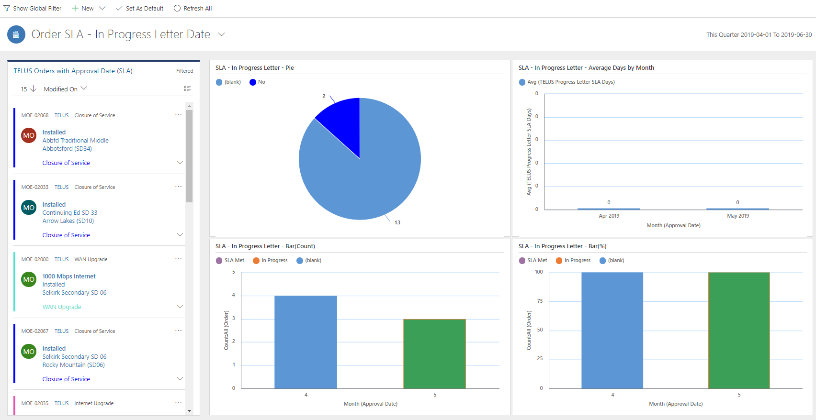

## Order SLA – Install Date

Security Roles: All

Apps: NGN App

Description: This interactive dashboard shows the installation date SLA and If it’s been met or not.

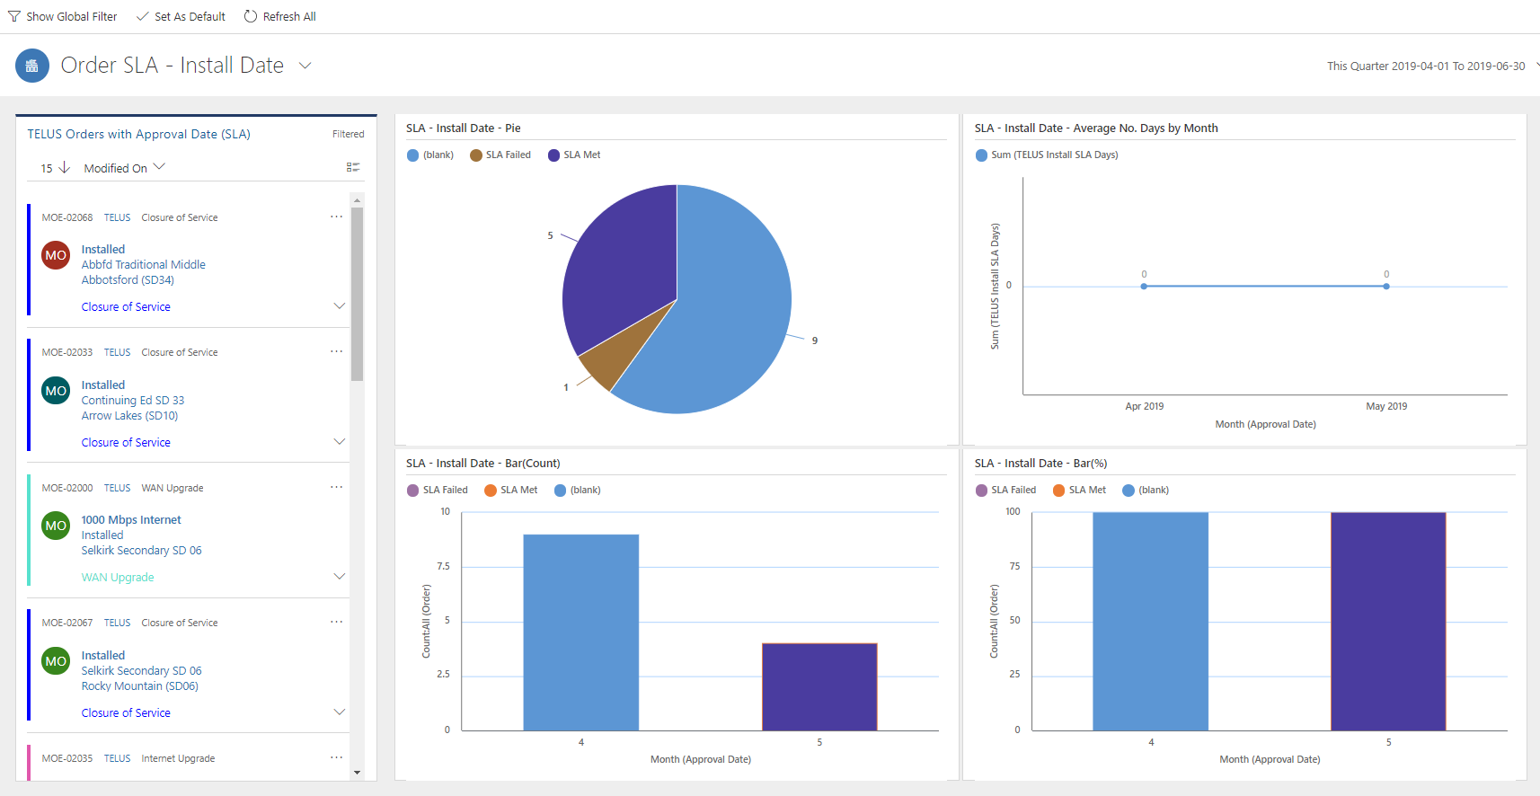

## Order Summary

Security Roles: All

Apps: NGN App

Description: An interactive dashboard showing a summary of order filtered by created date.

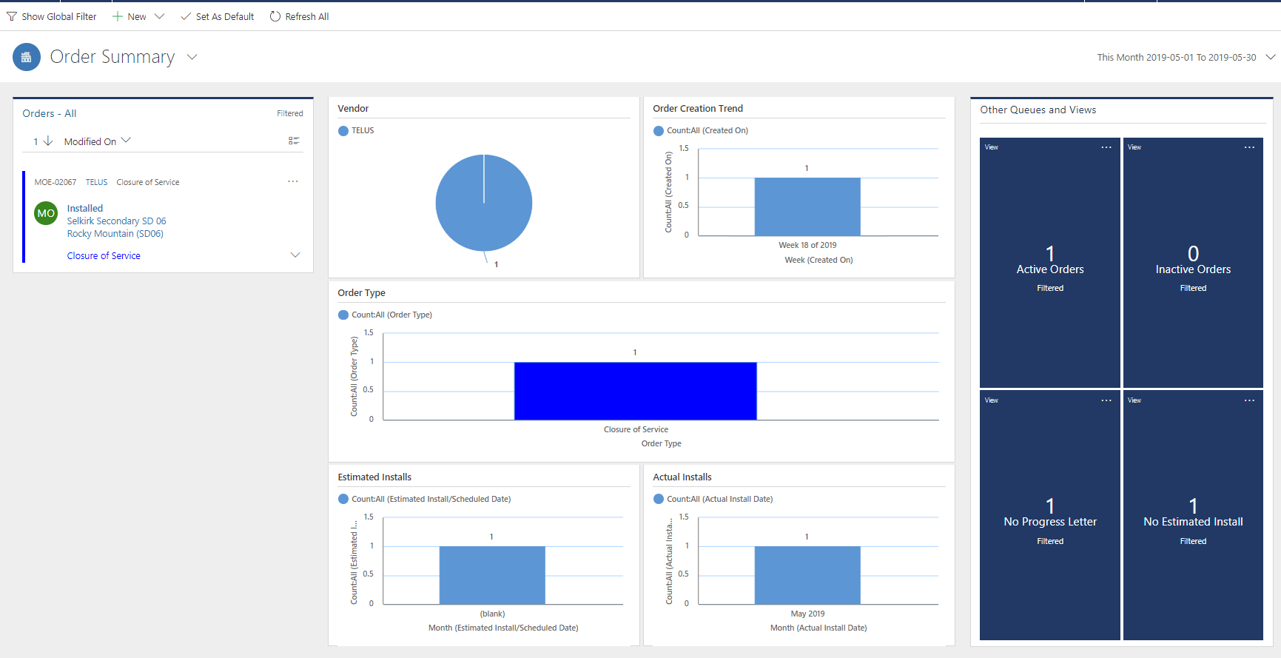

# Reports

There are no currently no custom reports in the system. Dynamics comes with plenty of out of the box reports, but we are not using them.